For the rest of this blog post I’ll assume that the following variables are defined and that you intend to use the functions of the **fitbitViz** package from the R Console (or RStudio IDE):

#..................

# parameter setting #..................

USER_ID = 'My user-id' # Specify here your 'user-id'

token = "My token" # Specify here your 'token'

WEEK = 11 # for this use case pick the 11th week of the year 2021

num_character_error = 135 # print that many character in case of an error

weeks_2021 = fitbitViz:::split_year_in_weeks(year = 2021) # split a year in weeks

# Start the week at monday

date_start = lubridate::floor_date(lubridate::ymd(weeks_2021[WEEK]), unit = 'weeks') + 1

# Add 6 days to the 'date_start' variable to come to a 7-days plot date_end = date_start + 6

sleep_time_begins = "00H 40M 0S" sleep_time_ends = "08H 00M 0S"

VERBOSE = FALSE # disable verbosity

The previous code snippet uses one week of my personal *Fitbit* data (the *11th week of 2021*) to plot my

**heart rate time series heart rate heatmap**

**heart rate variability during sleep time sleep time series**

**GPS data of outdoor activities 3-dimensional map of activities**

The pre-processed data of all these functions are also available to download by clicking on the

**CSV** buttons,

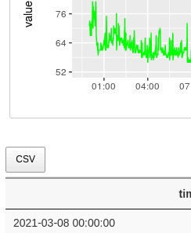

# heart rate time series

The **heart_rate_time_series()** function takes the **user-id**, **token**, the **start-** and **end-dates**, the **start-** and **end-time**, the **detail level** (1 minute) and returns the **heart rate time series**. Each output plot (of the *multiplot*) includes in the **x-axis** the **time** and in the **y-axis** the **heart rate value**. The highest heart rate value (peak) of the day is highlighted using a vertical and horizontal **blue** line,

#.......................

# heart rate time series #.......................

heart_dat = fitbitViz::heart_rate_time_series(user_id = USER_ID,

token = token, date_start =

as.character(date_start), as.character(date_end),

num_character_error) heart_dat$plt

date_end =

time_start = '00:00',

time_end = '23:59', detail_level = '1min', ggplot_intraday = TRUE, ggplot_ncol = 2,

ggplot_nrow = 4, verbose = VERBOSE, show_nchar_case_error =

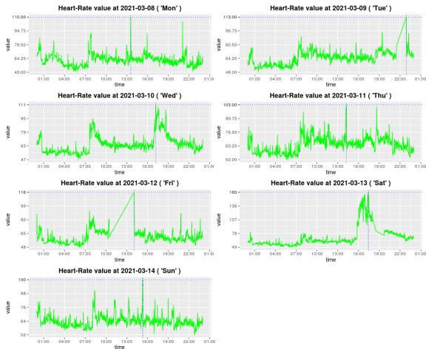

# heart rate heatmap

The **heart rate heatmap** shows the **min**, **median** and **max** heart rate Levels in the **y-axis** for each day of the specified week (**x-axis**). As the legend shows, the displayed values range from 40 to 220 and higher values appear in *purple* or *orange* color,

#............................

# heart rate intraday heatmap

#............................

heart_intra = heart_dat$heart_rate_intraday

hrt_heat = fitbitViz::heart_rate_heatmap(heart_rate_intraday_data = heart_intra,

angle_x_axis = 0)

hrt_heat

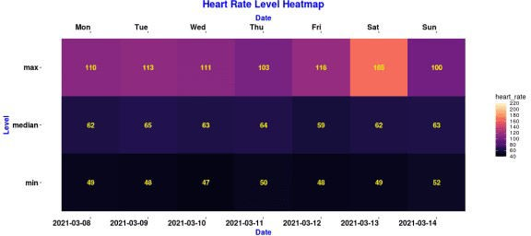

# heart rate variability during sleep time

This function computes the **root mean square of successive differences (RMSSD)** and a *higher heart rate variability is linked with better health*.

#.......................

# heart rate variability #.......................

hrt_rt_var = fitbitViz::heart_rate_variability_sleep_time(heart_ rate_data = heart_dat,

sleep_time_begins, sleep_time_ends,

= TRUE,

sleep_begin = sleep_end = ggplot_hr_var angle_x_axis

= 25)

hrt_rt_var$hr_var_plot

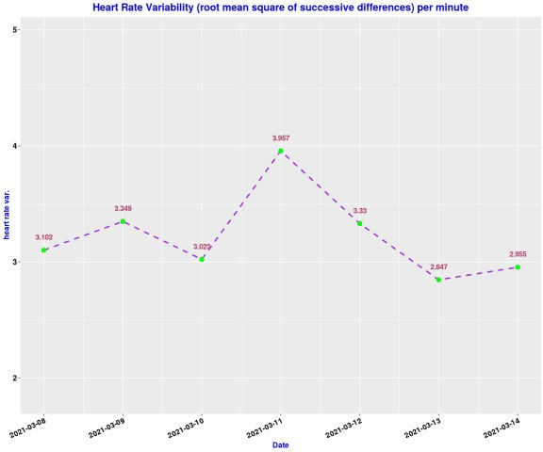

# sleep time series

The **sleep time series** visualization is similar to the *Fitbit Mobile* Visualization and in the **x-axis** shows the specified by the user **sleep time interval** whereas in the **y-axis** shows the **sleep Levels** (*wake*, *rem*, *light*, *deep*). Lower levels like *deep sleep* appear in dark blue whereas higher levels like *wake* appear in light blue,

#.......................

# sleep data time series #.......................

sleep_ts = fitbitViz::sleep_time_series(user_id = USER_ID,

token = token, date_start =

as.character(date_start),

date_end =

as.character(date_end), 'ggsci::blue_material',

num_character_error,

ggplot_color_palette = ggplot_ncol = 2,

ggplot_nrow = 4, show_nchar_case_error =

verbose = VERBOSE)

sleep_ts$plt_lev_segments

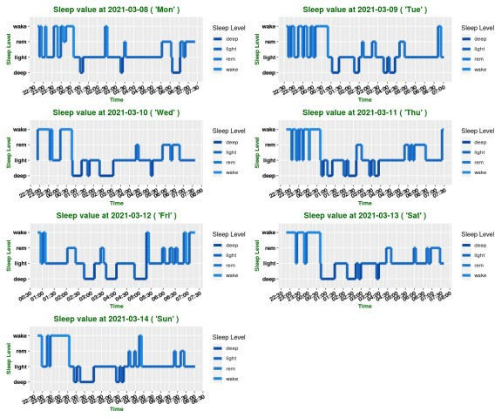

# GPS data of outdoor activities

To make use of the *GPS data* from the Fitbit Application we have first to extract the **log-id** for a time interval after a specified *Date*,

#...................

# extract the log-id (required for the GPS data) #...................

log_id = fitbitViz::extract_LOG_ID(user_id = USER_ID,

token = token, after_Date =

as.character(date_start),

# log_id

limit = 10, sort = 'asc',

verbose = VERBOSE)

Once we have the *log-id* we can define the *time zone* of the route to receive all GPS data,

#....................................................

# return the gps-ctx data.table for the output log-id #....................................................

res_tcx = fitbitViz::GPS_TCX_data(log_id = log_id,

user_id = USER_ID, token = token,

time_zone = 'Europe/Athens', verbose = VERBOSE)

# res_tcx

The following *Leaflet (Point Coordinates) Map* shows my outdoor activity during the *11th week of 2021* (the legend shows the elevation of the route),

#................................

# Create the Leaflet / LeafGL Map #................................

res_lft = fitbitViz::leafGL_point_coords(dat_gps_tcx = res_tcx,

color_points_column =

'AltitudeMeters', leaflet::providers$Esri.WorldImagery, rstudioapi::viewer,

provider = option_viewer = CRS = 4326)

res_lft

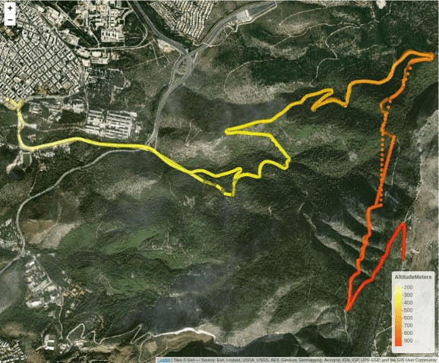

# 3-dimensional plots of activities

Another option of this package is to plot a route in 3-dimensional space. For this purpose we’ll use the rayshader package, which internally uses rgl (*OpenGL*). First, we have to extend the boundaries of our route for approximately *1.000 thousand meters* (adjust this value depending on your area of interest),

#...................................................

# compute the sf-object buffer and the raster-extend (1000 meters buffer)

#...................................................

sf_rst_ext = fitbitViz::extend_AOI_buffer(dat_gps_tcx = res_tcx,

buffer_in_meters = 1000,

CRS = 4326,

verbose = VERBOSE)

# sf_rst_ext

Then for the extended area we will download Copernicus Digital Elevation Model (DEM) data.

The *Copernicus elevation data* come either in **30** or in **90** meter resolution. We will pick the *30* meter resolution product for this route. The **CopernicusDEM** is an R package, make sure that you have installed and configured the **awscli** Operating System Requirement if you intend to download and reproduce the next 3-dimensional map using the elevation data.

#..................................................................

# Download the Copernicus DEM 30m elevation data

# there is also the option to download the DEM 90m elevation data # which is of lower resolution but the image size is smaller which # means faster download

#..................................................................

dem_dir = tempdir() # dem_dir

dem30 = CopernicusDEM::aoi_geom_save_tif_matches(sf_or_file = sf_rst_ext$sfc_obj,

dem_dir,

parallel::detectCores(),

dir_save_tifs =

resolution = 30,

crs_value = 4326, threads =

verbose = VERBOSE)

TIF = list.files(dem_dir, pattern = '.tif', full.names = T) # TIF

if (length(TIF) > 1) { #....................................................

# create a .VRT file if I have more than 1 .tif files #....................................................

file_out = file.path(dem_dir, 'VRT_mosaic_FILE.vrt')

vrt_dem30 = CopernicusDEM::create_VRT_from_dir(dir_tifs = dem_dir,

output_path_VRT =

file_out,

}

if (length(TIF) == 1) {

verbose = VERBOSE)

#..................................................

# if I have a single .tif file keep the first index #..................................................

file_out = TIF[1]

}

#.......................................

# crop the elevation DEM based on the

# coordinates extent of the GPS-CTX data #.......................................

raysh_rst = fitbitViz::crop_DEM(tif_or_vrt_dem_file = file_out,

sf_buffer_obj = sf_rst_ext$sfc_obj, CRS = 4326,

digits = 6, verbose = VERBOSE)

# sp::plot(raysh_rst)

The GPS route that I use is an *ascending & descending* route therefore we can convert the GPS (TCX) data to a spatial *LINESTRING* by using the maximum altitude as a *split point* of the route to visualize the ascending route in *blue* and the descending in *red* (there is also the alternative to specify the split point based on time using the **time_split_asc_desc** parameter),

linestring_dat = fitbitViz::gps_lat_lon_to_LINESTRING(dat_gps_tcx = res_tcx,

CRS = 4326,

time_split_asc_desc = NULL, VERBOSE

verbose =

then we create the *‘elevation_sample_points’ data.table parameter* for the *3-dim* plot based on the *min.*, *middle* and *max.* altitude of the previously computed *‘res_tcx’* data,

idx_3m = c(which.min(res_tcx$AltitudeMeters), as.integer(length(res_tcx$AltitudeMeters) / 2), which.max(res_tcx$AltitudeMeters))

cols_3m = c('latitude', 'longitude', 'AltitudeMeters') dat_3m = res_tcx[idx_3m, ..cols_3m]

and finally we visualize the *3-dimensional Rayshader Map*,

snapshot_rayshader_path = file.path(tempdir(), 'rayshader_img.png')

rgl::open3d(useNULL = TRUE) # this removes the second rgl-popup-window

fitbitViz::rayshader_3d_DEM(rst_buf = raysh_rst,

rst_ext = sf_rst_ext$raster_obj_extent, rst_bbx = sf_rst_ext$buffer_bbox, linestring_ASC_DESC = linestring_dat, elevation_sample_points = dat_3m,

zoom = 0.3,

windowsize = c(1000, 800))

rgl::rgl.snapshot(snapshot_rayshader_path)

rgl::par3d(mouseMode = "trackball") # options: c("trackball", "polar", "zoom", "selecting")

rgl::rglwidget()

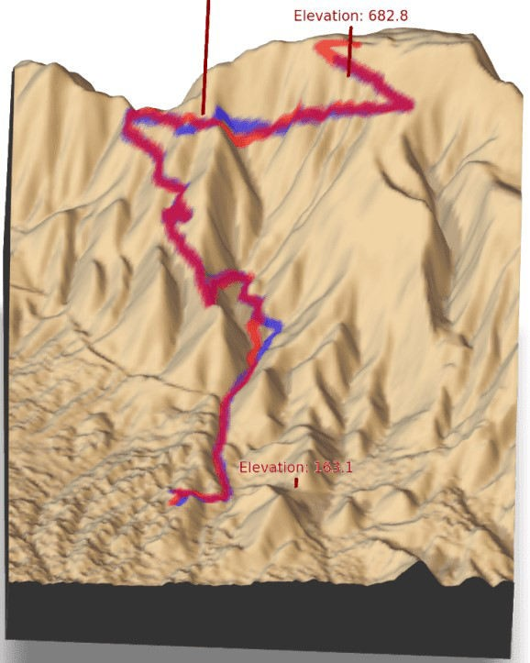

In the output map we observe

the *3 specified elevation vertical lines* (including their *altitude values* in meters) in *blue* color the *ascending* route

in *red* color the *descending* route

The attached map here is a screenshot.